**Name:**  **Fawad Iqbal**

**Reg No: FA21-BSE-012**

**Section: B**

# White Box Testing

# **An array with an odd number of elements is said to be centered if all elements (except the middle one) are strictly greater than the value of the middle element. Note that only arrays with an odd number of elements have a middle element. Write a function that accepts an integer array and returns 1 if it is a centered array, otherwise it returns 0.**

### 1. Program Unit:

public static int isCentered(int[] arr) {

if (arr == null || arr.length == 0) {

return 0;

}

if (arr.length % 2 == 0) {

return 0;

}

int middleIndex = arr.length / 2;

for (int i = 0; i < arr.length; i++) {

if (i != middleIndex && arr[i] <= arr[middleIndex]) {

return 0;

}

}

return 1;

}

### 2. Control Flow Graph:

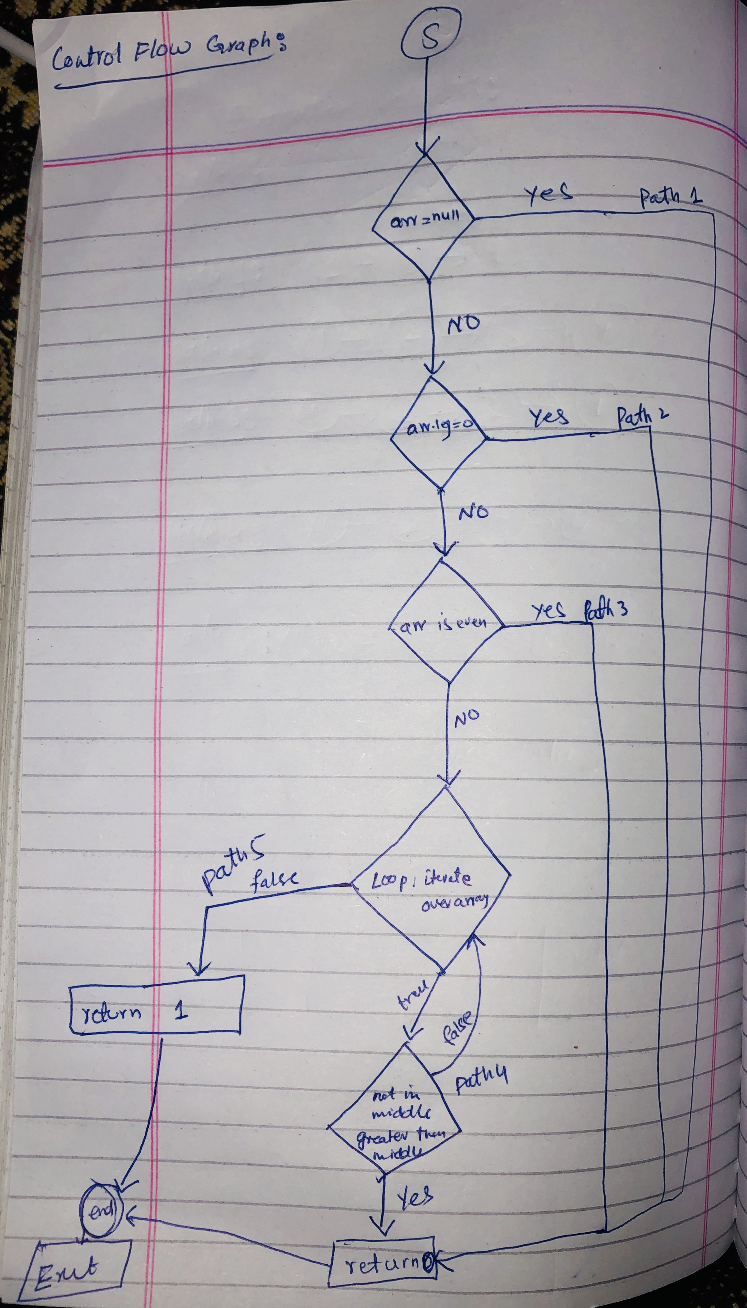

### 3. Identifying Execution instances (paths):

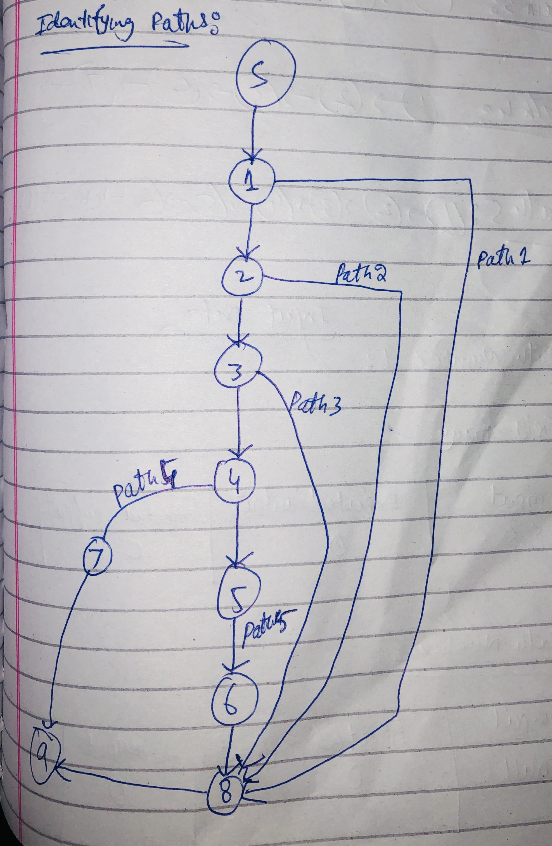

### 4. All Paths:

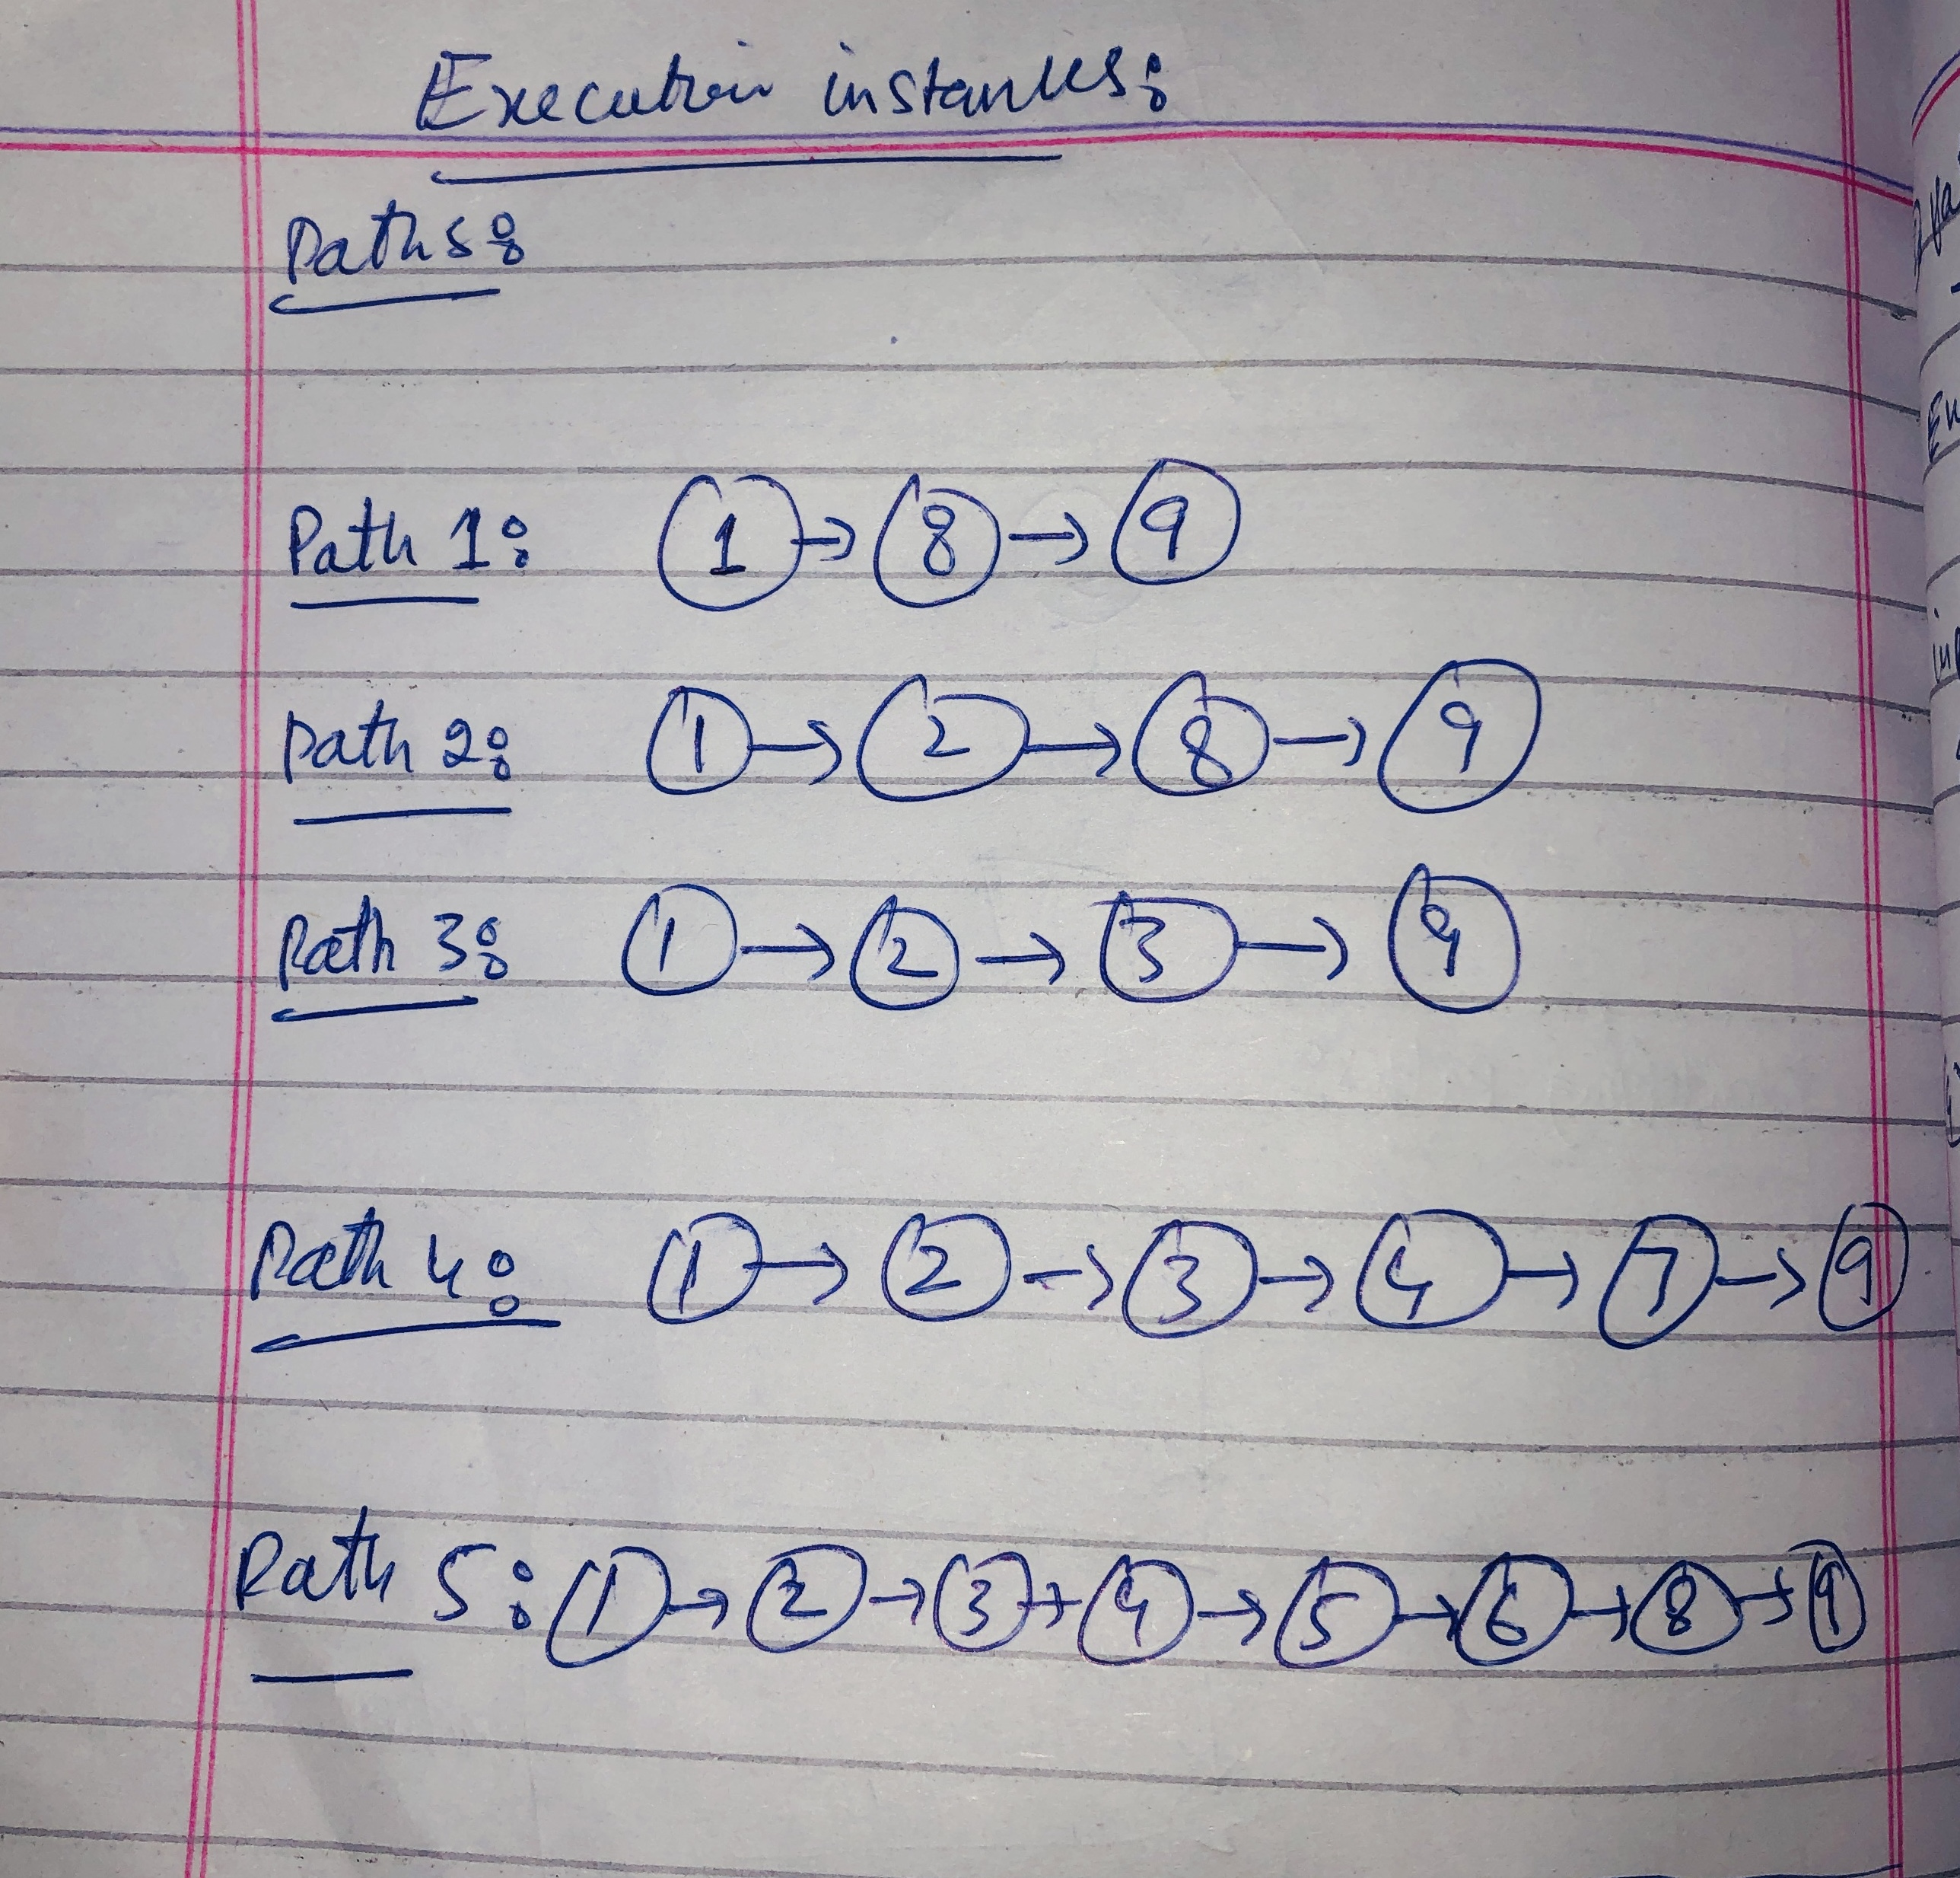

### 5. Input Data:

